INDEX.HTML FILE:--

index.html file:

<!DOCTYPE html>

<html lang="en" xmlns="http://www.w3.org/1999/html">

<head>

<meta charset="UTF-8">

<title>Title</title>

</head>

<body>

<div style="text-align: center;">

<form action="result.jsp">

<input type="radio" name="selection" value="addition" checked="checked">Addition</input><br>

<input type="radio" name="selection" value="subtraction">Subtraction</input><br>

<input type="radio" name="selection" value="multiplication">Multiplication</input><br>

<input type="radio" name="selection" value="division">Division</input><br> Enter first value <input type="number" name="firstValue"><br>

Enter second value <input type="number" name="secondValue"><br>

<input type="submit">

</form>

</div>

</body>

</html>

result.jsp file:

<%@ **page** import="java.io.PrintWriter" %><%--

--%>

<%@ **page** contentType="text/html;charset=UTF-8" language="java" %>

<html>

<head>

<title>Result of Calculator</title>

</head>

<body>

<%

float firstValue = Integer.*parseInt*(request.getParameter("firstValue"));

float secondValue = Integer.*parseInt*(request.getParameter("secondValue"));

String radio = request.getParameter("selection");

if("addition".equals(radio)){

out.println("Result: "+(firstValue+secondValue));

}

else if("subtraction".equals(radio)){

out.println("Result: "+(firstValue-secondValue));

}

else if("multiplication".equals(radio)){

out.println("Result: "+(firstValue*secondValue));

}

else if("division".equals(radio)){

out.println("Result: "+(firstValue/secondValue));

}

else{

request.getRequestDispatcher("/error.jsp").forward(request, response);

}

%>

</body>

</html>

result output:

**ADDITION:**

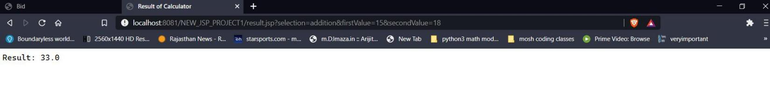

**SUBTRACTION:**

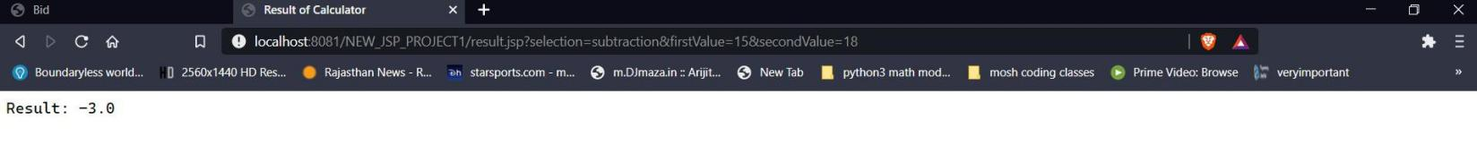

**MULTIPLY:**

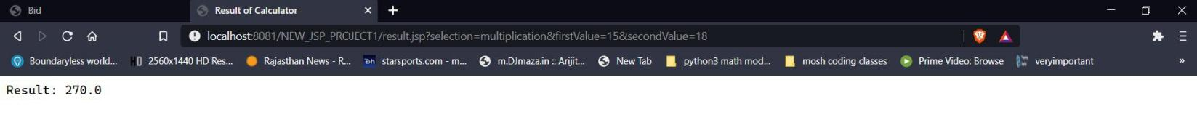

**DIVISION:**

